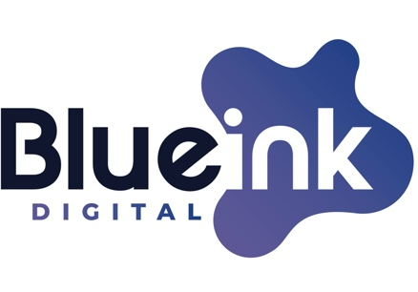

Re: Business Impact Statement
- 02-278 - Regulations Implementing the Telephone Consumer Protection Act
- 21-402 - Targeting and Eliminating Unlawful Text Messages.

Prepared by: Gregory Dobak, CEO Blue Ink Digital
Date: Thursday Jan 11th 2024

To Whom It May Concern:

We are writing this comment in response to the reopened comment period specifically relating to the FCC’s new One-to-One requirement.

The FCC new One-to-One requirement will significantly and negatively impact our business forcing us to make cuts to U.S. staffing and pay and will very negatively impact our hundreds of our U.S. clients who rely on lead generation services to stay in business, employ their workers and provide valuable services. The implementation of this rule will cause significant harm to the more than 2 million small businesses nationwide in our industry including the loss of high paying and cutting-edge tech jobs as well as negatively impacting hundreds of thousands of good paying jobs in dozens of industries that rely on lead generation services.

Blue Ink Digital is a U.S. based digital marketing company that typically employs between 6-10 U.S. workers in high paying tech jobs in the United States. Our company provides services for several hundred clients with the vast majority (95%+) being small businesses exclusively based in the U.S. and focused on the U.S market. Our clients typically employ 5-200 employees each.

Our main business model is that we help small business in the home service and residential solar industries find customers who are interested and looking for their services. We provide these services through what the FCC would describe as lead generation. As a company we provide a website and advertise nationwide to consumers allowing them to find a local home service company to fulfill their home service request. We pass each home service request to the most appropriate home service company in the consumer’s area. Our clients then call and text the leads to set up the home services requested by the consumer. Our clients (who are often busy providing services throughout the day) routinely use some form of automation to contact the consumers as quickly as possible and to automate the logistics of setting up an appointment. Whether this was intended or not, the FCC’s One-to-One requirement, as written, will impact millions of small U.S. businesses who rely on these methods to stay in business and offer their services at an affordable price.

As a marketing company, for us to advertise economically we need to advertise nationwide and then deliver the inquires to local professionals. There are more than 2 million home service businesses in the U.S. representing more than 6 million professionals. The One-to-One requirement will make it extremely difficult if not impossible for us to advertise for those clients. Furthermore, a very good portion of our clients are small businesses that do not have the expertise, capital or ability to advertise digitally and much of their business relies upon companies like ours to connect them to consumer’s looking for that service that would not otherwise be able to find them.

While large companies may be able to navigate around this, small companies will see their cost of marketing increase significantly (already typically their biggest single expense) or lead generation services will stop offering to take on smaller companies entirely. Unfortunately, it is unlikely that even a small fraction of percentage of these small businesses know about this change or how it will impact their business given they largely rely upon lead generators for all of their technical or customer acquisition needs.

This change is akin to asking a carrot farmer to specify the exact grocery store that the carrot will be sold in before digging up the carrot. With a lot of cost and effort, the farmer may be able to specify the largest grocery chains but if the farmer is forced to implement this change the farmer would likely not sell to small local grocery stores given the logistical and regulatory burden being too high.

This rule will increase costs, reduce consumer access, and needlessly burdens too many legitimate small businesses. The FCC’s quest to limit unwanted texts and calls is noble and we very much support targeted efforts at eliminating fraud and spam message. However, this change will cause direct harm to our business including the immediate loss of high paying tech jobs that support small businesses in the home services and solar industry and we urge the FCC to reconsider based on the huge and very negative impact this change will have.

